
‘Microlearning: Product knowledge’ Blueprint Storyboard
Generated by Elucidat Learning Accelerator

[Your business name]
[Your project title]

Use this simple storyboard to plan and generate the content you want to put across in your chosen Elucidat Blueprint.
It helpfully provides a page-by-page structure, with examples and guidance to help you and your collaborators deliver the right content, in the right way, for an engaging elearning experience, that works.

Contents

Before you start… 3
Overall structure and content 4

Before you start…
This storyboard maps to the Microlearning: Product knowledge Blueprint, created by Elucidat’s experienced learning design team. It’s a tried and tested method for creating a clear digital asset that quickly communicates the essential details of a policy change, company update, or other piece of information you want to share with your audience.

What kind of content works well for a Microlearning: Product knowledge project?
- Think about what the audience needs to know. Keep the information you include tightly focused on what your audience need to know – what impact will this have on how they do their jobs? What do you want them to do with this information?
- Pre-empty frequently asked questions. Consider the types of questions your audience might have about the product, and what customers might ask them. This will help you make sure you’ve covered the most important elements.

See an example of great content used in this template here

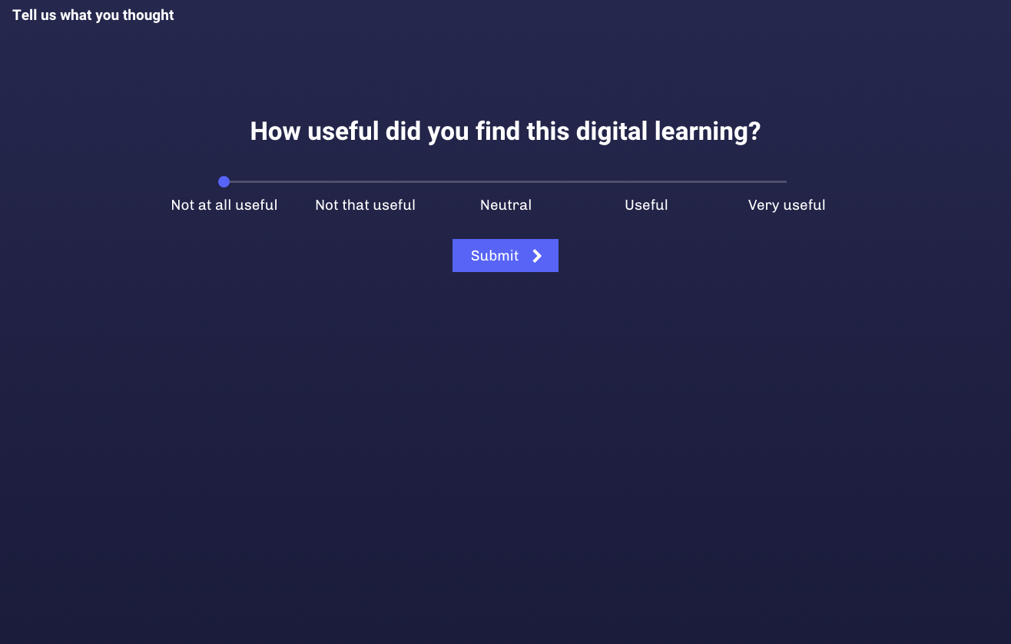
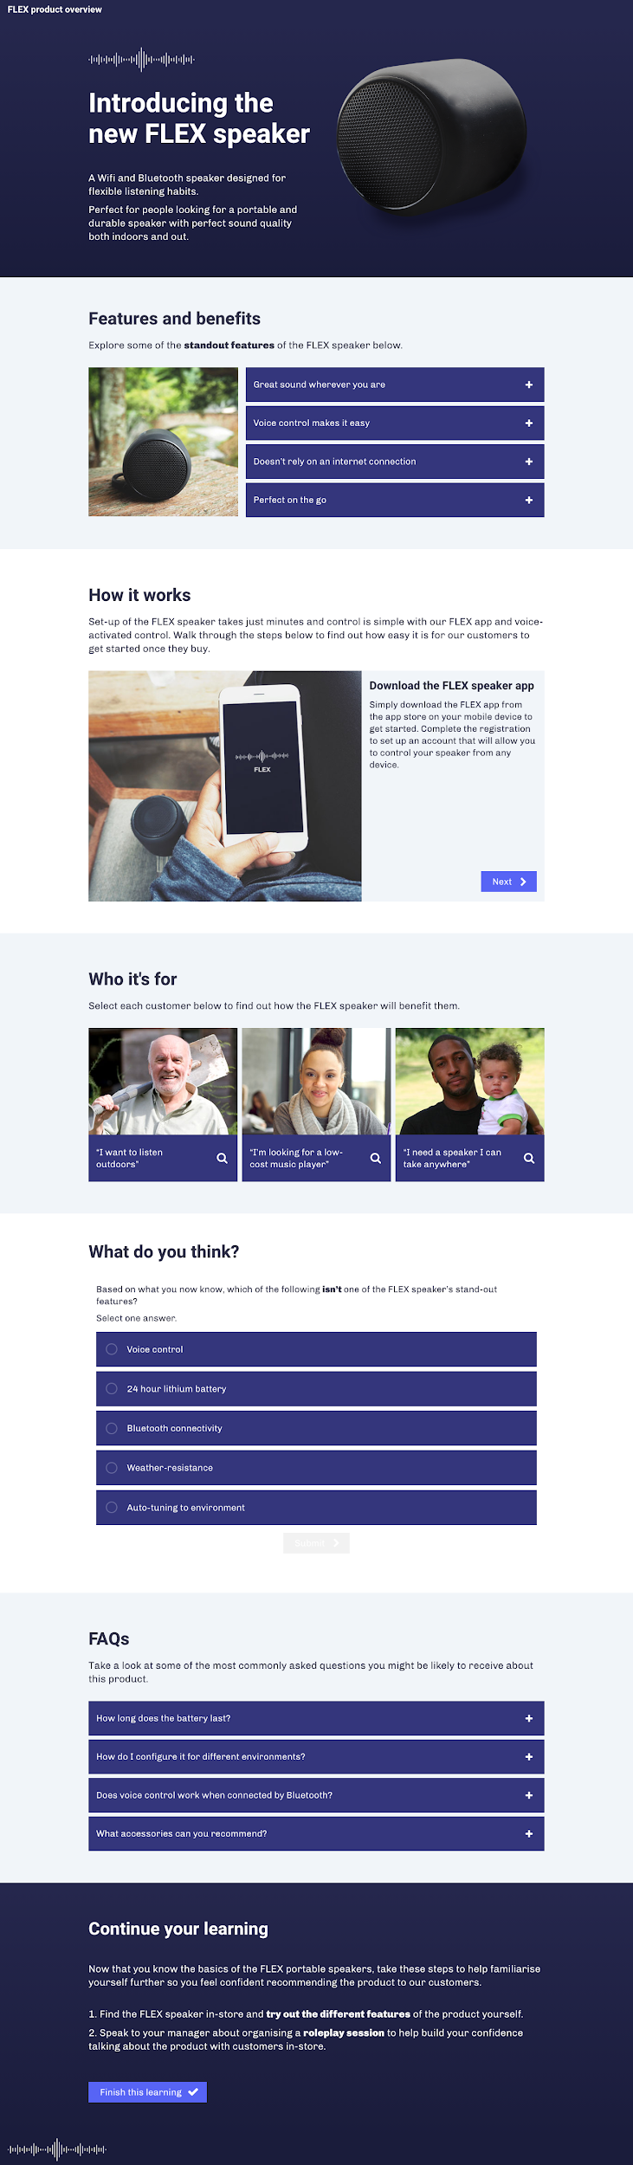
Overall structure and content
This diagram represents the flow of this Blueprint.

As you can see it’s one main scrolling page with focused sections, followed by a short user survey page. Each section is shown below in the storyboard table.

Page type: Product Training Scrolling Page

Section: Banner
What’s this section for? Introducing your product.

Page title: All about [Your Product]
Text: Introduce what this product is all about, in a nutshell, here.

Imagine you're pitching the product and need to summarise it in 30 words.

Section: Features and benefits
What’s this section for? Listing the main features of your product.

Title: Features and benefits
Text: Write a short 10 word intro line such as 'Explore the key features below'.

BELOW: Use the headings as a guide to describe this product. Edit these as you see fit but aim for around 8 words each.

Heading 1: What are its strengths?
Display text 1: Describe where this product stands out.
What situations is it best placed to be used?
What needs does it most meet?
Try to use no more than 50 words.

Heading 2: What are its drawbacks?
Display text 2: Where does it fail to deliver?
What needs does it definitely not meet?
Try to use no more than 50 words.

Heading 3: Which products does it go well with?
Display text 3: What other products complement this one?
Try to use no more than 50 words.

Heading 4: What other products are similar?
Display text 4: What other products is this similar to? Help the learner make connections.
Try to use no more than 50 words.

Section: How does it work (with text and images)
What’s this section for? Giving learners a demo of the product and how it works. Use this section for your demo when you have text and images but no video available of the product.

Title: How does it work? (image & text option)
Intro text: Write a short 10 word intro line like 'Walk through a brief demo to understand how it works'.

BELOW: Use the interaction below to walk through how the product works

Text 1: 1.

If you were a customer using this, what might you do first?

OR, what feature do you want to highlight?

Explain how it works in small steps, this being the first. Use up to 40 words, spaced out.

Use the image area to show a photo or illustration of this step in action.

Text 2: 2.

If you were a customer using this, what might you do next?

OR, what feature do you want to highlight?

Explain how it works in small steps, this being the first. Use up to 40 words, spaced out.

Use the image area to show a photo or illustration of this step in action.

Text 3: 3.

If you were a customer using this, what might you do now?

OR, what feature do you want to highlight?

Explain how it works in small steps, this being the first. Use up to 40 words, spaced out.

Use the image area to show a photo or illustration of this step in action.
Section: How does it work (with video)  What’s this section for? Giving learners a demo of the product and how it works. Use this section for your demo when you have a video of the product you can upload. If not, delete this section of the page.  Title: How does it work? (video option)  Intro text: Write a short 10 word intro line like 'Watch this brief demo to see how it works'.  BELOW: Got a video that shows the product in action? Upload or embed it here. | 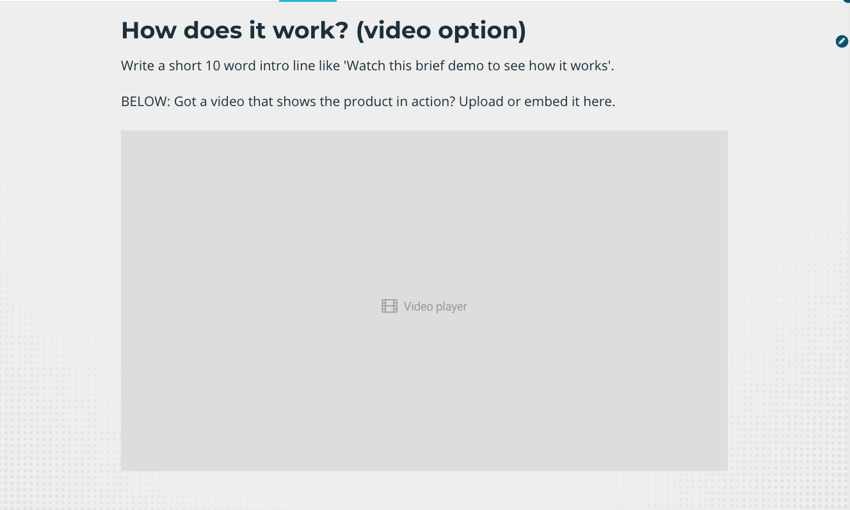
Section: Customer needs
What’s this section for? Explaining how the product can fit customers’ needs.

Title: Who might need a product like this?
Intro text: Write a short 10 word intro line such as 'Explore how the product maps to customer needs'.

BELOW: Create mini customer stories to show how the product maps against different customer needs. Open up the hotspots to reveal more on how to do this.

Heading 1: Customer title 1
Display text 1:
Customer title 1 - a summary of their need, perhaps
Why not make a statement from the viewpoint of your sample customer? State what need they have, in a concise and human way, using "speech marks".

Explain how the product does and doesn't meet their needs.

Consider using bullets to show what does
And what doesn't meet their needs
Is there another product that might work better or equally well for them?

Aim for no more than 50 words.

Heading 2: Customer title 2
Display text 2:
Customer title 2 - a summary of their need, perhaps
Why not make a statement from the viewpoint of your sample customer? State what need they have, in a concise and human way, using "speech marks".

Explain how the product does and doesn't meet their needs.

Consider using bullets to show what does
And what doesn't meet their needs
Is there another product that might work better or equally well for them?

Aim for no more than 50 words.

Heading 3: Customer title 3
Display text 3:
Customer title 3 - a summary of their need, perhaps
Why not make a statement from the viewpoint of your sample customer? State what need they have, in a concise and human way, using "speech marks".

Explain how the product does and doesn't meet their needs.

Consider using bullets to show what does
And what doesn't meet their needs
Is there another product that might work better or equally well for them?

Aim for no more than 50 words.
Section: Try it out
What’s this section for? Giving learners a chance to try a question to test out their knowledge of the product.

Title: Have a try
Intro text: Ask learners a 10-20 word question here, to help embed their product knowledge. For example, 'which of the following is true/unique/a benefit of the product?'
You can use this space to add additional information or give useful instructions such as 'Select an option below, then Submit'.

Option 1: Type your answer here – make them all roughly the same length
Feedback 1:
How did you do?
This text will show if learners choose option 1.Say if this option was right or not. Present your feedback in a way that doesn't sound like a teacher, but takes an adult to adult tone. Explain why this option was or wasn't right, as this is the bit that supports learning.

Option 2: Type your answer here – make them all roughly the same length
Feedback 2:
How did you do?
This text will show if learners choose option 2. Say if this option was right or not. Present your feedback in a way that doesn't sound like a teacher, but takes an adult to adult tone. Explain why this option was or wasn't right, as this is the bit that supports learning.

Option 3: Type your answer here – make them all roughly the same length
Feedback 3:
How did you do?
This text will show if learners choose option 3.Say if this option was right or not. Present your feedback in a way that doesn't sound like a teacher, but takes an adult to adult tone. Explain why this option was or wasn't right, as this is the bit that supports learning.

Section: FAQs
What’s this section for? Giving learners the information they will need to address some frequently asked questions about the product.

Title FAQs
Intro text? BELOW: Write 2 -5 commonly asked questions about this product, from staff or customers. Aim for no more than 10 words.

What's the answer? Open the tabs for further guidance.
Heading 1: Write a frequently asked question here in 10-15 words.
Display text 1: What is the clearest way you can give the answer to that question?

Do so here.

Use bold and bullets to separate out points as needed and keep it short!

Heading 2: Write a frequently asked question here in 10-15 words.
Display text 2: What is the clearest way you can give the answer to that question?

Do so here.

Use bold and bullets to separate out points as needed and keep it short!

Heading 3: Write a frequently asked question here in 10-15 words.
Display text 3: What is the clearest way you can give the answer to that question?

Do so here.

Use bold and bullets to separate out points as needed and keep it short!

Section: Take it further
What’s this section for? Giving learners a clear direction about where they should take the learning now and what they should do next.

Title Take it further
Intro text? This is really important! What should your learner do next?

Set one or two clear actions they should go and do.

- Might it be to go an explore the product for themselves?
- Change these bullets as you need to.

Make this section concise and targeted - aim for no more than 30 words.

Page type: Learner survey
What’s this section for? Capturing learners’ feedback on the module. You can leave the text on this page as it is.

Title: Tell us what you thought
Text: Before you exit, we’d love to hear your feedback!
How useful did you find this digital resource?
Slider:

Not at all useful | Not that useful | Neutral | Useful | Very useful

